PFS Health-Check pfs_hc_v1.3py Installation:-

1. Copy the tar file to the jump box.
2. Create SSH trusts from jump box to all PFS Active and Standby servers.
3. Untar ‘pfs_hc_v1.3tgz’ in some directory

*tar -xvzf pfs_hc_v1.3.tgz*

1. Step 3 will create the folder ‘PFS3903_HC’ with the files as shown in screenshot below

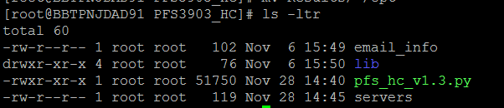

pfs_hc_v1.py🡪 pfs script in python.

servers 🡪 active pfs servers info

lib 🡪 library files required for the script

email_info 🡪 email information

1. Add only **Active** PFS servers info in **servers** file

for e.g.

[root@BBTPNJDAD91 PFS3903_HC]# cat servers

*#ServerIP,username,password,timeout*

*10.143.182.59,administrator,netscout1,60*

*10.143.136.59,administrator,netscout1,60*

1. Add email info in **email_info** file as follows

*FROM: pfshc@netscout.com*

*TO: syed.rehman@netscout.com*

*SUBJECT: PFS Health Check*

*SMTP: 10.194.80.114*

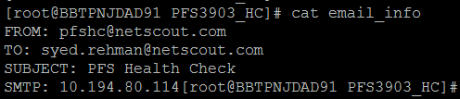

1. Change the **FOLDER** variable the script to full folder path of ‘PFS3903_HC’



1. Run the script as

**./pfs_hc_v1.3py -f servers -e email_info**

1. **Results** folder will get generated with the output files at the end of execution and email will be sent out to the address configured in email_info.

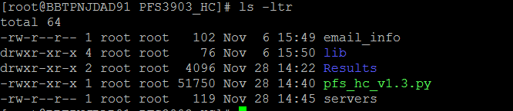

*** Please do not remove **Results,** as script will check the last health-check time from “Last_Scan_time” and compare if there are any new error. For the first run there will be no comparison.

1. **FOR TACAS users only**

If TACAS authentication supports only dynamic password, script can only be run manually. Please set TACAS parameter to **True.**  The script will ask user login and password during run time otherwise if False it will take the user name and password from servers file.



For any issues related to this script please reach out to

[Syed.rehman@netscout.com](mailto:Syed.rehman@netscout.com)

[Keyur.Patel@netscout.com](mailto:Keyur.Patel@netscout.com)